Mimecast Domain Setup
- Access the Mimecast Administration Console via https://login-us.mimecast.com/administration/
- Add all domains that will be utilized for email, including TENANT.onmicrosoft.com to Mimecast
To add domains, navigate to Administration > Directories > Internal Directories
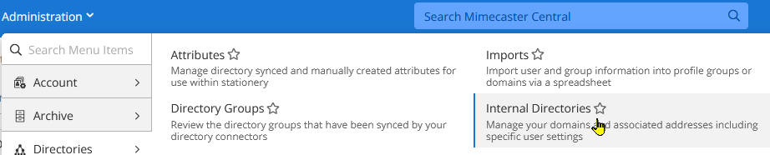
- Click on the Register New Domain button
- Enter the domain name at the bottom of the page to complete step 1
- Press the Get Verification Code button
- Add the required TXT record to the domain via the public DNS registrar such as Cloudflare or GoDaddy
- Once the TXT record exists in the public DNS, click the Validate button at the bottom of the page
- Point Mimecast to 365 MX record
- If all information was entered correctly, the domain will be successfully validated as displayed on the Summary page
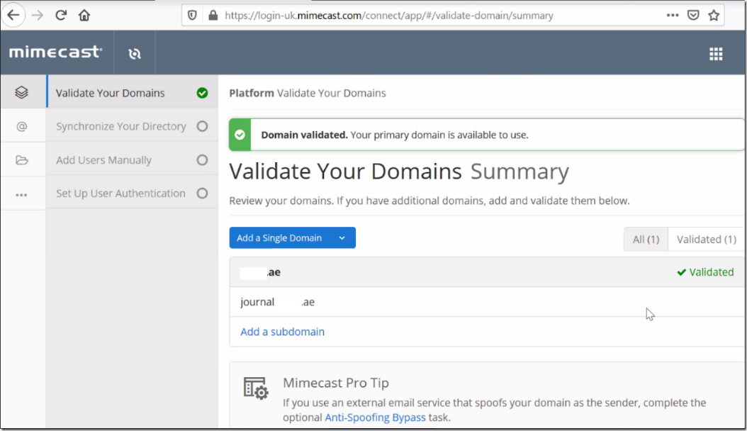
- Keep this page open as it will be needed after the Azure configuration in the next section

Setup Directory Synchronization in Azure
- Login to the client Azure Active Directory portal
- Click on App Registrations > New Registration
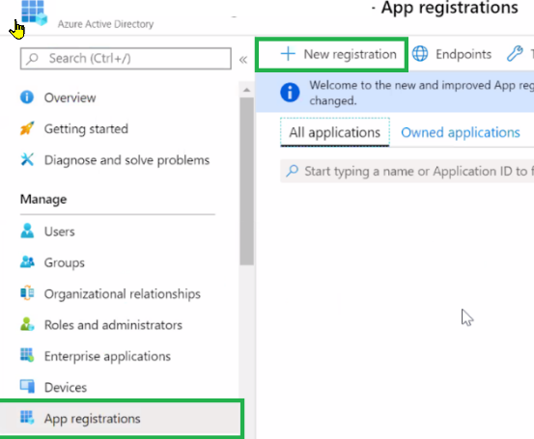
- Enter Mimecast AD Sync for the application name
- Select the “Accounts in this organizational directory only” radio button
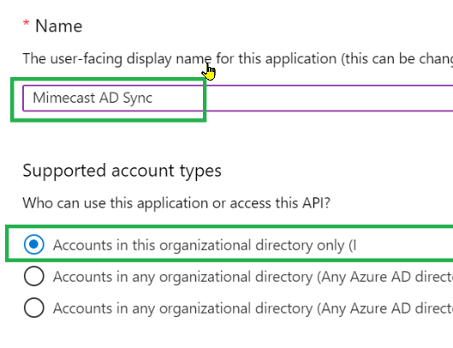
- Press the blue Register button

- Gather the Application (Client) ID for the Mimecast console and save it

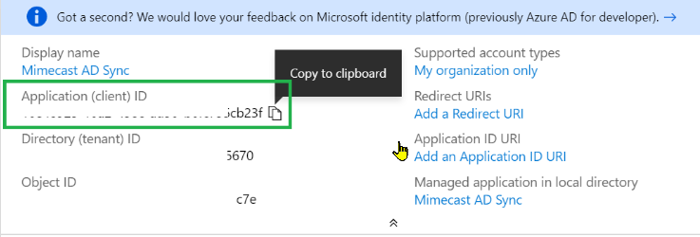
- Click on Certificates and Secrets
- Click on New client secret
- Enter Mimecast to O365 for the description
- Choose 24 months for the expiration date
- IMPORTANT: Copy and save the Client Secret Value, it will not be available after you leave this page. It will be needed later
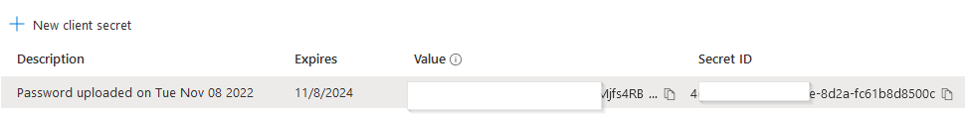
- Navigate to Enterprise Applications > Mimecast AD sync > API Permissions
- Click on + Add a permission, then click on Microsoft Graph
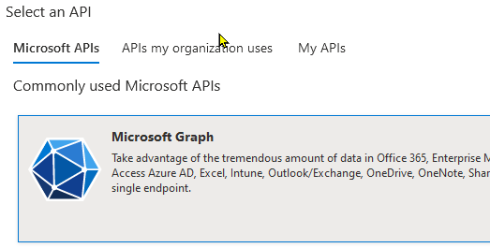
- Add Application permission: Directory > Directory.Read.All and User > User.Read.All

- Add Delegated permission: User > User.Read.All
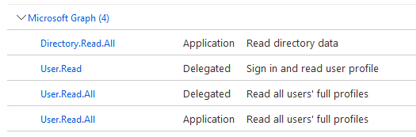
- You will want to wait 10 – 15 minutes before proceeding.

Setup Mimecast Directory Synchronization
- Go back to Mimecast Administrator portal and go to Services > Directory Synchronization > Create Directory Integration
- Enter Azure Directory Synchronization in the Name field
- Enter a description
- Select Type Microsoft Azure – Standard
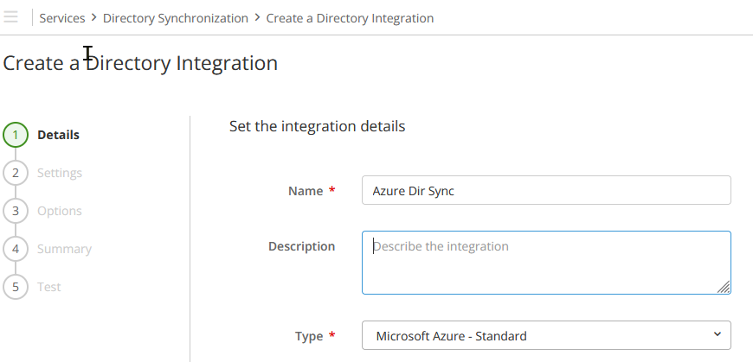
- Enter the Application ID, Key, and Tenant Domain, then press Next
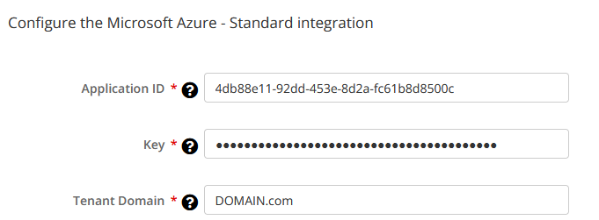
- Select Acknowledge Disabled Accounts, Include Contacts, Delete Users and press Next
- Synchronization is now configured
- Review the entered data, toggle Status if you’re not ready to use this feature yet, press Next
- If all checks pass, select Create Integration, press Finish

Office 365 Connection Filter Configuration
- Log on to the Microsoft 365 Admin Center
- Click on the Security menu item
- Click on the Policies & rules menu item
- Select Threat policies
- Select Anti-spam
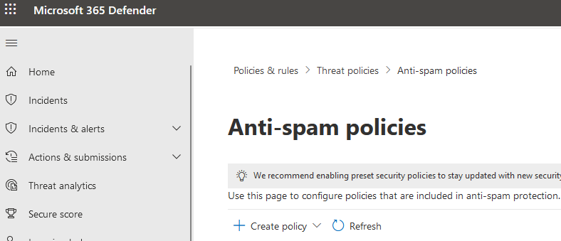
- Select the Connection filter policy, then select Edit connection filter policy
- Give the filter a Description
- Click on Edit connection filter policy
- On the Always allow messages from the following IP addresses or address range, add the Inbound Mimecast IP Ranges
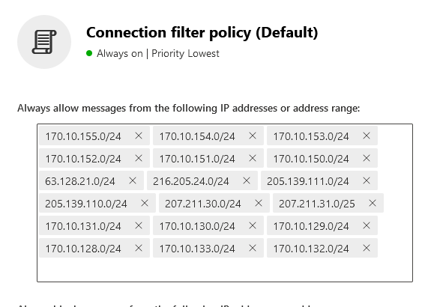
The updated Mimecast IP information can be found at the following link: https://community.mimecast.com/s/article/Adding-Network-Ranges-to-Office-365

Exchange 365 Outbound Connector Configuration
- Login to the 365 Exchange Admin Center
- Go to Mail Flow > Connectors and click on the Add a connector
- Select Connection from Office 365 and connection to Partner Organization
- Name the connector O365 Outbound to Mimecast, then choose Next
- Select Only when I have a transport rule set up that redirects messages to this connector, then press Next
- Select Route email through these smart hosts, then enter the two entries for Mimecast
  - us-smtp-o365-outbound-1.mimecast.com
  - us-smtp-o365-outbound-2.mimecast.com
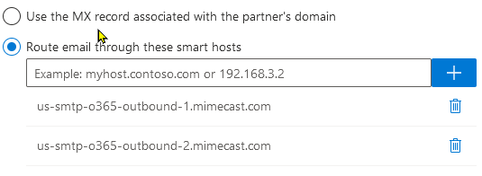
- Make sure Always use Transport Layer Security (TLS) to secure the connection (recommended) and Issued by a trusted certificate authority (CA) are selected, then press Next
- Enter a validation email account
- Press Validate
- Press Next
- Press Save

Exchange 365 Transport Rule Configuration
- Login to the Exchange 365 Administrator portal
- Go to Mail Flow > Rules, click Add Rule, select New rule
- Name transport rule Outbound to Mimecast
- Apply this rule if the recipient is located Outside the organization, press Save
- Press the + to add another condition
- Add an and condition to apply this rule, If the sender domain is the tenant primary domain (microsoft.com, etc.)
- Select Do the following, and select Redirect the message to… and select the Outbound to Mimecast connector you created
- Press Next, then Next, then Finish
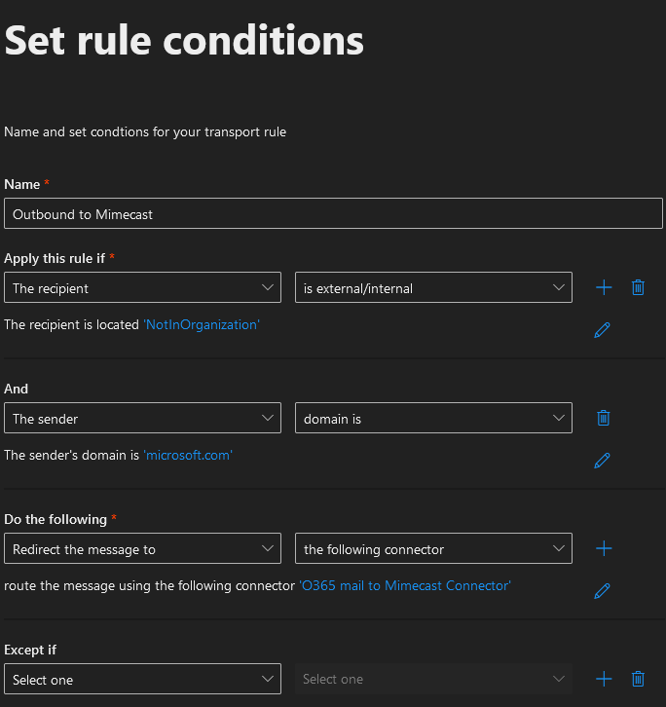

Exchange 365 Inbound Connector Configuration
- Login to the 365 Exchange Admin Center
- Go to Mail Flow > Connectors and click on the Add a connector
- Select Connection from Partner organization, select Connection to Office 365, press Next
- Name connector Mimecast to O365, press Next
- Select By verifying that the sender domain matches…, enter * and press the +
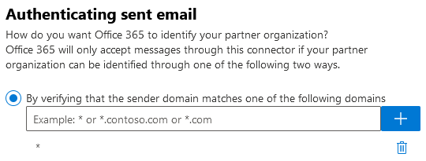
- Select ‘Reject email messages if they aren’t sent over TLS’
- Select ‘Reject email messages if they aren’t sent from within this IP range
  - Add the Mimecast subnets: https://community.mimecast.com/s/article/Adding-Network-Ranges-to-Office-365#us
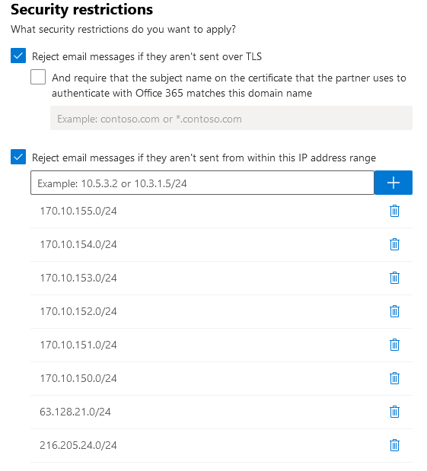
- Press Next
- Press Create connector
- Press Done

Office 365 Journaling with Mimecast Configuration

Create an Office 365 Journaling Contact
- Logon to Exchange 365 Administrator portal
- Go to Recipients > Contacts
- Click Add a mail contact
- Fill out the basic information
  - First Name: Journaling
  - Last Name: Mimecast
  - Display Name: Journaling for Mimecast
  - Alias: Journaling
  - External Email Address: journaling@journal.domain.com
- Press Next again
- Review the information entered and press Create

Create an Office 365 Journaling Send Connector
- Logon to Exchange 365 Administrator portal
- Go to Mail Flow > Connectors
- Click Add a connector
- Select From Office 365
- Select To Partner Organization
- Press Next
- Name connector Office 365 to Mimecast Journaling
- If you are ready to enable the connector, leave the Turn it On box checked, if not uncheck it
- Click Next
- Select Only When Email Messages are Sent to These Domains, type the domain *.journaling.DOMAIN.com and click the + button
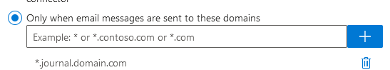
- Press Next
- Select Route email through these smart hosts and enter the below Mimecast hostnames
  - us-smtp-journal-1.mimecast.com
  - us-smtp-journal-2.mimecast.com
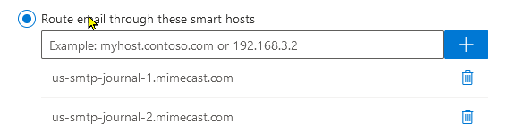
- Press Next
- Select the following security restrictions
  - Always use Transport Layer Security (TLS) to secure the connection
  - Issued by a trusted certificate authority (CA)
- Press Next
- Enter the journaling email used to create the journaling contact
  - journaling@journal.domain.com
- Press Validate
- Press Save

Create an Office 365 Journaling Rule
- Login to the Compliance 365 Administrator Portal (compliance.microsoft.com)
- Go to Data lifecycle management > Exchange (legacy) > Journal rules
- Click New rule
- Enter your journal contact email into the Send journal reports to field
  - journaling@journal.domain.com
- Name rule O365 Journal Rule
- Select Journal messages sent or received from Everyone
- Select All messages for Type of message to journal
- Press Next, then review the information entered
- Press Submit if correct

Configuring a Journal Definition in Mimecast
- Login to the Mimecast Administration Console
- Navigate to Administration > Services > Journaling
- Click New Journal Service Definition
- Enter a name in the description
- Select SMTP for Transport type
- Complete the Connection Properties Service Email Address with the contact email created in O365
  - journaling@journal.domain.com
- IP Ranges can be left blank. If you need to add O365 IP ranges here, you will have to contact Mimecast support
- Select Use SMTP Authentication
  - Enter password
- Leave the default value in Initial Process Delay and Delivery Wait Attempts
- Period of Inactivity Allowed: Default is 180 mins
- Journal Type: Exchange
- Encrypted: leave enabled
- Rest can be left alone
- Save and exit

Configuring Journaling Subdomain in Mimecast
- Login to the Mimecast Administration Console
- Navigate to Administration > Directories > Internal Directories
- Select Add Subdomain button
- Domain: journal.domain.com
- Accept all inbounds for this domain
- Leave anti-spoofing unselected

Verifying Microsoft 365 Premium Journaling
- Once your journaling configuration is complete, verify that the connections are working:
- Log on to the Mimecast Administration Console.
- Navigate to Administration > Services > Journaling
- Click on the Queue Details button to list the journaling items.
- If the connector configuration isn't successful, see the Troubleshooting Journaling page:
  - https://community.mimecast.com/s/article/Troubleshooting-Journaling-874318225?r=46&ui-knowledge-components-aura-actions.KnowledgeArticleVersionCreateDraftFromOnlineAction.createDraftFromOnlineArticle=1

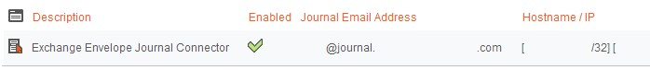

Conclusion
Before mail will route through Mimecast, the following needs to be configured:
- Public DNS MX record should point to Mimecast
  - Records can be obtained from: https://community.mimecast.com/s/article/Office-365-Configuring-Outbound-Delivery-Routing-1430192975
  - Use the following:
    - us-smtp-inbound-1.mimecast.com
    - us-smtp-inbound-2.mimecast.com
- All O365 connectors created will need to be turned on
- Azure AD Sync will need to be enabled in Mimecast
- Public DNS domain SPF record will need to be updated to include Mimecast

